

2020 Year 11 ViSN Mathematics Specialist Units 1 & 2
Test 6 – Complex numbers & Proof
Section One – Calculator Free

Mr Daniel Comtesse  Mandurah Catholic College | Calculator Free:______/  Calculator Assumed:_____/
daniel.comtesse@cewa.edu.au | Result: _____/ ______%

Student Name: ___________________________________________

School: ___________________________________________

Time allowed: Section One - minutes

Section Two – minutes

Assessment Date:

Material required/recommended

To be provided by the supervisor
This Question/Answer Paper
SCSA Formula Sheet

To be provided by the candidate
Standard items: pens, pencils, pencil sharpener, eraser, correction fluid/tape, ruler, highlighters

Submission Details
Timed Assessments are to be returned to the ViSN teacher by the ViSN mentor (scan completed assessment and email to teacher above) within 24 hours of assessment date (above).

Instructions to Students
1. ALL questions should be attempted.

2. Write your answers in the spaces provided in this Question/Answer Booklet.

3. SHOW ALL YOUR WORKING CLEARLY. Your working should be sufficient detail to allow your answers to be checked readily and for marks to be awarded for reasoning. Correct answers given without supporting reasoning may not be allocated full marks. Incorrect answers given without supporting reasoning cannot be allocated any marks.

4. If you repeat an answer to any question, ensure that you cancel the answers you do not wish to have marked.

5. It is recommended that you do not use pencil, except in diagrams.

Question 1 [3, 3 = 6 marks]
(a) Determine the values of the real constants $b$ and $c$ if $z=1+3i$ is a solution of the equation $z^{2}+bz+c=0$.

(b) Express the real quadratic polynomial $z^{2}-4z+8$ as a product of its linear factors.

Question 2 []
(a) A set of real numbers is given by $\left\{ \sqrt{2}, 3.\overline{14}, π, \sqrt[3]{14} \right\}$. Clearly show that one of the numbers in the set is rational.

(b) Prove that $9.\overline{9}≡10$.

Question 3 []
Let $z_{1}$ and $z_{2}$ be complex numbers such that $2z_{1}+3z_{2}=7$ and $z_{1}+iz_{2}=4+4i$.
Determine $z_{1}$ and $z_{2}$ in the form $z=a+bi$, where $a, b ∈Z.$

End of Section One
Additional working space

Question number: _________



2020 Year 11 ViSN Mathematics Specialist Units 1 & 2
Test 6 – Complex numbers & Proof
Section Two – Calculator Assumed

Mr Daniel Comtesse  Mandurah Catholic College | Calculator Assumed:_____/
daniel.comtesse@cewa.edu.au

Student Name: ___________________________________________

School: ___________________________________________

Time allowed: Section One - minutes

Section Two – minutes

Assessment Date:

Material required/recommended

To be provided by the supervisor
This Question/Answer Paper
SCSA Formula Sheet

To be provided by the candidate
Standard items: pens, pencils, pencil sharpener, eraser, correction fluid/tape, ruler, highlighters
Special items: 1 A4 (one sided) page of notes, up to three scientific and/or CAS calculators

Submission Details
Timed Assessments are to be returned to the ViSN teacher by the ViSN mentor (scan completed assessment and email to teacher above) within 24 hours of assessment date (above).

Instructions to Students
1. ALL questions should be attempted.

2. Write your answers in the spaces provided in this Question/Answer Booklet.

3. SHOW ALL YOUR WORKING CLEARLY. Your working should be sufficient detail to allow your answers to be checked readily and for marks to be awarded for reasoning. Correct answers given without supporting reasoning may not be allocated full marks. Incorrect answers given without supporting reasoning cannot be allocated any marks.

4. If you repeat an answer to any question, ensure that you cancel the answers you do not wish to have marked.

5. It is recommended that you do not use pencil, except in diagrams.

Question 4 []
Show that if $n$ is one more than a multiple of three, then $n^{2}$ will also be one more than a multiple of three, where $n∈Z$.

Question 5 [1 mark each]
The complex numbers $u$ and $v$ are shown in the complex plane below.
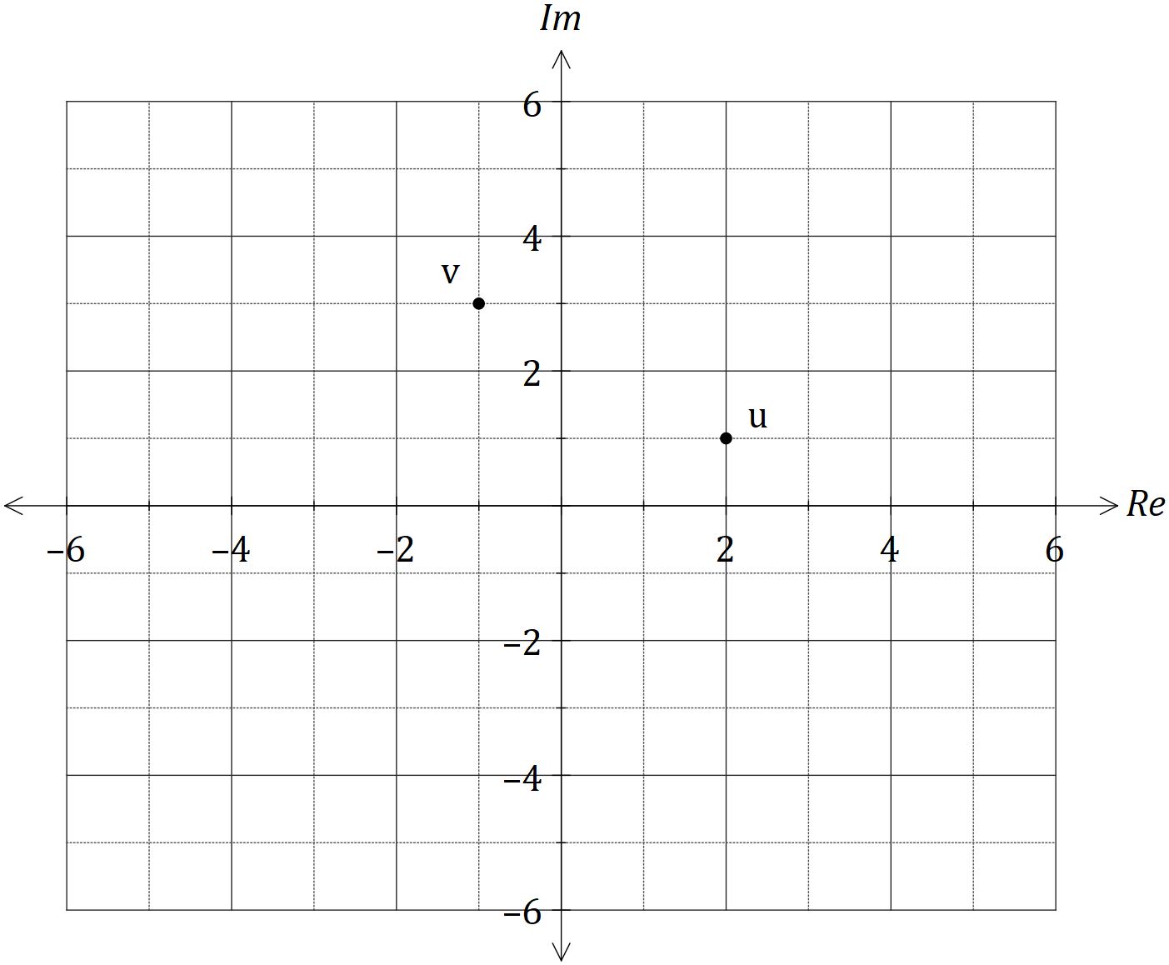
Plot and label the following complex numbers:

(a) $z_{1}=u+v$

(b) $z_{2}=2v-u$

(c) $z_{3}=\overline{v}$

(d) $z_{4}=\overline{u+v}-\overline{u}-\overline{v}$

Question 6 []
Prove that $\sqrt{7}$ is irrational by contradiction.

Question 7 [2, 4 = 6 marks]
The sum of the first $n$ terms of the sequence $2+8+14+20+ .. +\left(6n-4\right)$ is $n(3n-1)$.

(a) Show that the statement is true when $n=5$.

(b) Use mathematical induction to prove the statement is true for $n∈Z ,n≥5$.

Question 8 [5 marks]
Use mathematical induction to prove that $7^{2n-1}+5$ is always divisible by $12$, for $n∈N$.

End of Assessment
Additional working space

Question number: _________

